**Documentation**

**Overview of Business:**

Dern-Support, an IT technical support company serving businesses and individuals, offers computer repair services both on-site and through drop-off/courier options. With growth, they recognize the need for a better system to handle customer accounts, support requests, repairs, spare parts inventory, scheduling, and data analysis efficiently.

**Summary of the Problem:**

Customer management at Dern-Support lacks efficiency due to the absence of a centralized system. Account setup, support request tracking, repair management, and quoting are handled manually, resulting in inefficiencies and the risk of errors.

Individual customers encounter inconvenience with limited accessibility options, as they are required to either personally drop off their computers at Dern-Support's offices or organize courier services. There's a pressing need for a more accessible and convenient solution tailored to their needs.

Accessibility to a comprehensive knowledge base is lacking for both customers and support technicians at Dern-Support. This deficiency results in extended resolution times and increases the potential for errors in diagnosing and resolving issues.

Job scheduling and prioritization at Dern-Support are inefficient, as they rely on manual processes. This approach may result in suboptimal resource utilization and longer response times for customers. Additionally, the prioritization of jobs lacks a streamlined process, further exacerbating operational challenges.

**Proposed Solution:**

Developing a comprehensive software solution to address these pain points is imperative for Dern-Support to enhance efficiency, customer satisfaction, and overall business performance. The solution should encompass the following key features:

* Customer Management System: A centralized system for setting up accounts and tracking support requests, repairs, and quotes.
* Online Portal for Individual Customers: An intuitive online portal where individual customers can submit requests, track progress, and communicate with support staff.
* Integrated Knowledge Base: A robust knowledge base accessible to both customers and support technicians, providing comprehensive information on common issues, troubleshooting steps, and repair guides.
* Inventory Management Module: A dedicated module for managing spare parts inventory, enabling easy tracking, updates, and alerts for low stock levels.

**Functional and non-functional requirements:**

**Functional Requirements:**

Customer Account Management:

* Users can create and manage individual or business customer accounts.
* Account creation requires basic information such as name, contact details, and address.
* Customers can update their profile information as needed.

Support Request Submission:

* Customers can submit support requests through the software platform.
* Support request form includes fields for issue description, device details, and preferred repair date/time.
* Customers receive confirmation upon successful submission of a support request.

Quote Generation:

* Upon receiving a support request, the system generates a quote for the cost of the job based on predefined pricing rules.
* Quotes include breakdown of costs (labor, parts, etc.) and total price.

Knowledge Base Access:

* Customers and support technicians can access the knowledge base to diagnose and troubleshoot issues.
* Search functionality enables users to find relevant troubleshooting guides and instructions.

Spare Parts Management:

* Staff can search for spare parts in stock based on criteria such as part number, name, or category.
* Authorized users can update details of spare parts, including quantity, location, and price.

Job Scheduling and Prioritization:

* Support staff can schedule repair jobs based on availability and customer preferences.
* Prioritization logic considers factors such as urgency, customer type, and service level agreements (SLAs).

**Non functional requirements:**

Performance:

* The system must respond to user interactions promptly, with minimal latency.
* It should be capable of handling multiple concurrent users without significant degradation in performance.

Scalability:

* The solution should be scalable to accommodate increasing numbers of users, support requests, and data volume as the business grows.
* Scalability should be achieved through horizontal and vertical scaling approaches.

Reliability:

* The system should be reliable, with minimal downtime for maintenance or unexpected failures.
* Data integrity must be maintained to prevent loss or corruption of customer and operational data.

Security:

* Access to sensitive information such as customer details and repair job data must be restricted based on user roles and permissions.
* The system should employ encryption protocols to ensure the security of data transmission and storage.

Usability:

* The user interface should be intuitive and user-friendly, requiring minimal training for both customers and staff.
* Navigation should be logical, and actions should be easily discoverable.

Accessibility:

* The software solution should be accessible to users with disabilities, complying with accessibility standards and guidelines.
* Support for assistive technologies such as screen readers should be incorporated.

**key performance indicators (KPIs):**

**Customer Satisfaction Rating:** Measure the overall satisfaction of customers with the support provided through the software solution. This can be collected through post-service surveys or direct feedback mechanisms.

**Average Response Time:** Track the average time taken from when a support request is submitted to when it is acknowledged or assigned to a technician. A lower average response time indicates efficient handling of support requests.

**First-Time Fix Rate:** Calculate the percentage of support requests that are resolved successfully on the first attempt without the need for additional follow-up or rework. A higher first-time fix rate reflects the effectiveness of problem diagnosis and resolution.

**Job Completion Time:** Monitor the average time taken to complete repair jobs from the moment they are scheduled to when they are marked as completed. Decreasing job completion time indicates improved operational efficiency.

**Inventory Turnover Rate:** Evaluate how quickly spare parts are used and replaced within the inventory. A higher turnover rate suggests efficient management of inventory levels and timely restocking of essential parts.

**Customer Retention Rate:** Measure the percentage of customers who continue to use Dern-Support's services over a specified period. A higher retention rate indicates customer satisfaction and loyalty.

**Risks and implications:**

**Technical Risks:**

* **Integration Challenges:** Integrating the software solution with existing systems and infrastructure may pose technical challenges and compatibility issues.
* **Scalability Concerns:** Ensuring that the solution can scale effectively to accommodate future growth in customer base and workload without compromising performance.
* **Data Security:** Risks associated with data breaches, unauthorized access, or data loss, especially considering the sensitive customer and business data being handled.

**Operational Risks:**

* **Disruption to Operations:** The transition to the new software solution may disrupt ongoing operations if not properly planned and executed, potentially leading to downtime and service interruptions.
* **Training and Adoption:** Ensuring that staff members are adequately trained to use the new system and that customers are familiar with the new processes and interfaces.
* **Dependency on Technology:** Risks associated with dependency on technology, such as system failures, software bugs, or technical issues impacting service delivery.

**Financial Risks:**

* **Cost Overruns:** The project may incur higher-than-anticipated costs due to factors such as scope creep, unexpected technical challenges, or changes in requirements.
* **ROI Uncertainty:** There may be uncertainties regarding the return on investment (ROI) of the software solution, particularly if the expected benefits, such as increased efficiency or customer satisfaction, are not realized as projected.

**Regulatory and Compliance Risks:**

* **Data Privacy Regulations:** Compliance with data privacy regulations such as GDPR or HIPAA, particularly concerning the handling of customer data and personal information.
* **Industry Standards:** Ensuring that the software solution meets industry-specific standards and regulatory requirements relevant to the IT support and repair industry.

**Mitigation Strategies:**

* Conduct thorough risk assessments and develop risk mitigation plans to address identified risks.
* Implement robust security measures to protect sensitive data and ensure compliance with relevant regulations.
* Plan for effective change management and communication strategies to minimize disruption during the implementation phase.
* Continuously monitor and evaluate the performance of the software solution post-implementation, addressing any issues or concerns promptly.
* Establish contingency plans and alternative solutions to mitigate the impact of unforeseen risks or disruptions.

**Flowchart for design:**

**Explain the design:**

First this the home page contains Definition of Company and information about it.

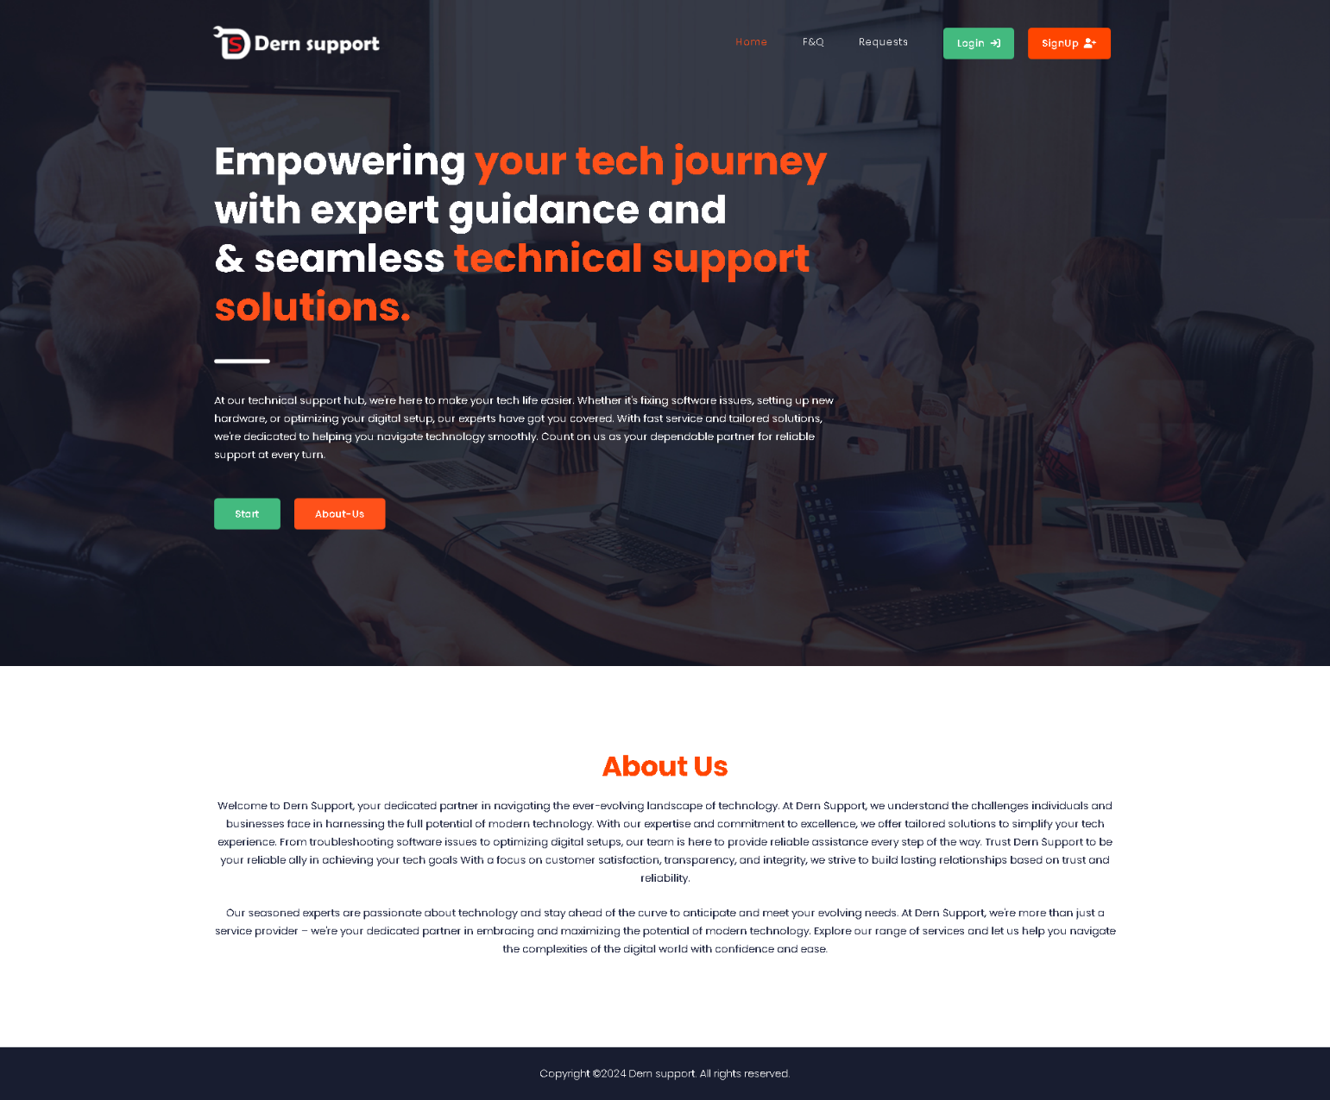

Second page is problems and their solution: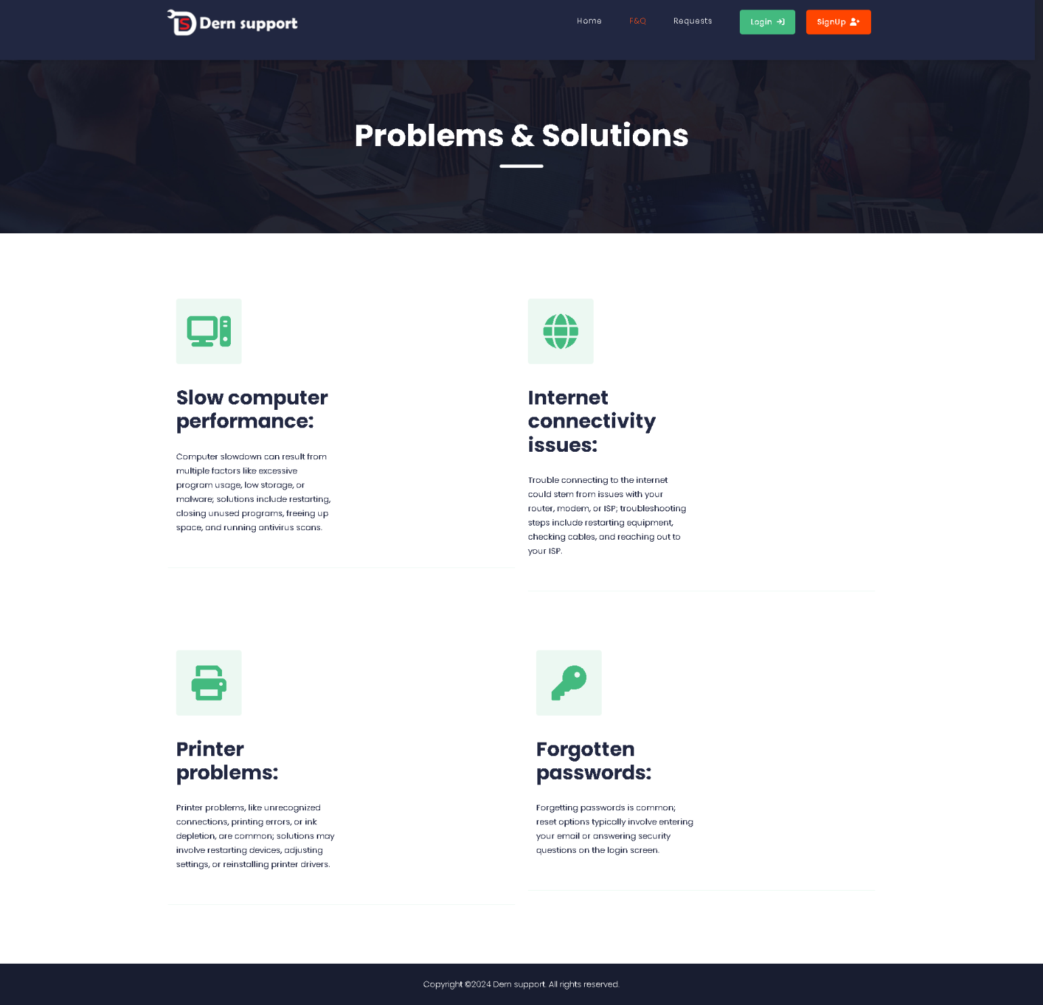

When click on submit the request going to database:

If user entered an invalid email or email doesn’t exists, the warning alert will appear:

After user login It will be go to home page:

Now the spare parts page will appear to businesses account:

And you can add new item when click on add new item: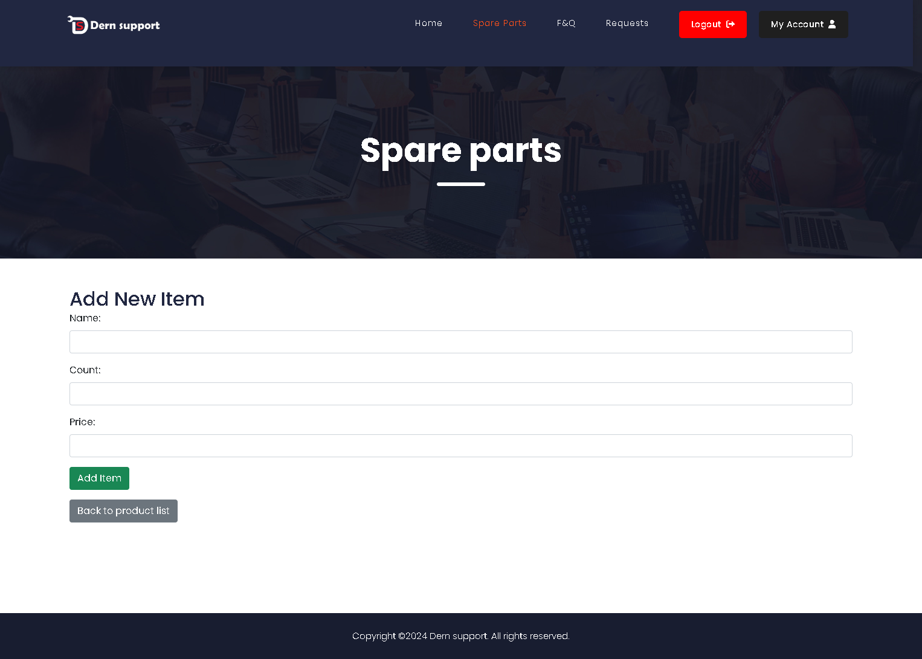

When add item the item will be store in database:

Now when you click on my account button your information will appear in page with your information:

Finally, when click on the logout button you logout from website and home page will appear.